A Cell-Phone Based Brain-Computer Interface for Communication in Daily Life
Yu-Te Wang , Yijun Wang , and Tzyy-Ping Jung

Swartz Center for Computational Neuroscience, Institute for Neural Computational
University of California, San Diego
La Jolla, CA, USA
{yute, yijun, jung}@sccn.ucsd.edu
Abstract. Moving a brain-computer interface from a laboratory demonstration to real-life applications poses severe challenges to the BCI community. Recently, with advances in the biomedical sciences and electronic technologies, the development of a mobile and online BCI has obtained increasing attention in the past decade. A mobile and wireless BCI based on customized Electroencephalogram recording and signal processing modules has the advantage of ultimate portability, wearability and usability. This study integrates a mobile and wireless EEG system and a signal-process platform based on a Bluetooth-enabled cell-phone into a truly wearable BCI. Its implications for BCI were demonstrated through a case study in which the cell-phone was programmed to assess steady-state, visual-evoked potentials in response to flickering visual stimuli to make a phone call directly. The results of this study on ten normal healthy volunteers suggested that the proposed BCI system enabled EEG monitoring and on-line processing of unconstrained subjects in real-world environments.
Keywords: Brain-computer interface (BCI), Electroencephalogram (EEG), Steady-state Visual-evoked potentials (SSVEP), Wireless data transmission.
1 Introduction
Brain-computer interface (BCI) systems acquire electroencephalography (EEG) signals from the human brain and translate them into digital commands which can be recognized and processed on a computer or computers using advanced algorithms [1]. BCIs can provide a new interface for the users suffering from motor disabilities to control assistive devices such as wheelchairs. Over the past two decades, different features of EEG signals such as mu/beta rhythms, event-related P300 potentials, and visual evoked potentials (VEP) have been used in BCI studies. Among these different BCI regimes, the VEP-based BCI has obtained increasing attention due to its advantages including high information transfer rate (ITR), little user training, low user variation, and ease of use [2].
Steady-state visual evoked potential (SSVEP) is the electrical response of the brain to the flickering visual stimulus at a repetition rate higher than 6 Hz [3]. The SSVEP is characterized by an increase in amplitude at the stimulus frequency, which makes it possible to detect the stimulus frequency based on the measurement of SSVEPs. The frequency coding approach has been widely used in SSVEP-based BCI systems [4]-[9]. In such a system, each visual target is flickering at a different frequency. The system can recognize the gaze target of the user by detecting the dominant frequency of the SSVEP. Although robustness of the system performance has been demonstrated in many laboratory studies, moving this BCI system from a laboratory demonstration to real-life applications still poses severe challenges to the BCI community [9]. To design a practical BCI system, the following issues need to be addressed: (1) ease of use, (2) reliable system performance, (3) low-cost hardware and software. Recently, with advances in the biomedical sciences and electronic technologies, the development of a mobile and online BCI has been put on the agenda [10].
In real-life applications, BCI systems should not use a bulky, wired EEG acquisition device and signal processing platform [11]. Using these devices will not only uncomfortable and inconvenient for the users, but will also affect their ability to perform routine tasks in real life. Furthermore, signal processing of BCI systems should be in real-time instead of off-line analysis. Several studies have demonstrated the use of portable devices for BCIs [12]-[17]. Lin et al. [12] proposed a portable BCI system that can acquire and analyze EEG signals with a custom DSP module for real-time monitoring. Shyu et al. [17] proposed a system to combine an EEG acquisition circuit with an FPGA-based real-time signal processer. To the best of our knowledge, a cellphone-based online BCI platform has not been reported.
This study aimed to integrate a wearable and wireless EEG system [12] with a mobile phone to implement an SSVEP-based BCI. The system consists of a four-channel biosignal acquisition/amplification module, a wireless transmission module, and a Bluetooth-enabled cell-phone. This study also demonstrates its implications in a case study in which wearers’ EEG signals were used to directly make a phone call. Real-time data processing was implemented and carried out on a regular cell-phone. In a normal office environment, an average information transfer rate (ITR) of 28.47 bits/min was obtained from ten healthy subjects.
2 Methods

2.1 System Hardware Diagram
A typical VEP-based BCI that uses frequency coding consists of three parts: visual stimulator, EEG recording device, and signal processing unit [2]. The basic scheme of the proposed mobile and wireless BCI system is shown in Fig. 1Fig. 1. The hardware of this system consists mainly of three major components: a stimulator, an EEG acquisition unit and a mobileecell-phone.

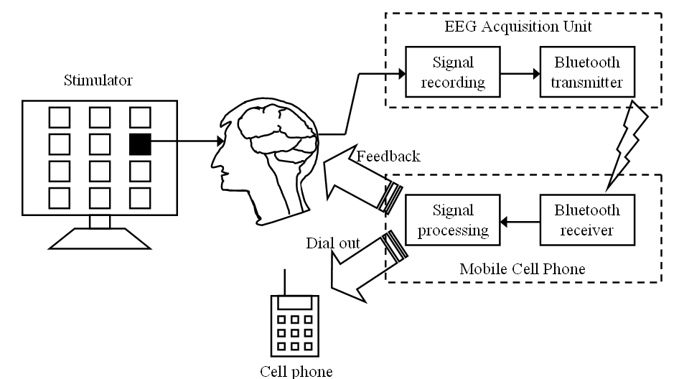
Fig. 1. System diagram of mobile and wireless BCI.
The visual stimulator comprises a 21-inch CRT monitor (140Hz refresh rate 800x600 screen resolution) with a 4 x 3 stimulus matrix constituting a virtual telephone keypad which includes digits 0-9, BACKSPACE and ENTER. The stimulus frequencies ranged from 9Hz to 11.75Hz with an interval of 0.25Hz between two consecutive digits. The stimulus program was developed in Microsoft Visual C++ using the Microsoft DirectX 9.0 framework.
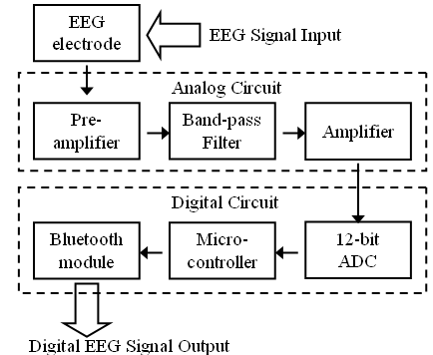
(a)
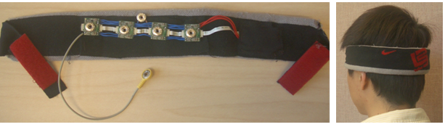
(b)
Fig. 2. (a)Block diagram of the EEG acquisition unit, (b) an EEG headband with an embedded data acquisition and wireless telemetry unit.

The EEG acquisition unit is a 4-channel wearable bio-signal acquisition unit. Fig. 2Fig. 2(a) shows the data flow of EEG acquisition unitError: Reference source not found[11]. EEG signals were amplified (8,000x) by instrumentation amplifiers, Band-pass filtered (0.01-50 Hz), and digitized by analog-to-digital converters (ADC) with a 12-bit resolution. To reduce the number of wires for high-density recordings, the power, clocks, and measured signals were daisy-chained from one node to another with bit-serial outputs. That is, adjacent nodes (electrodes) are connected together to (1) share the power, reference voltage, and ADC clocks, and (2) daisy-chain the digital outputs. Next, TI MSP430 was used as a controller to digitize EEG signals using ADC via serial peripheral interface with a sampling rate of 128Hz. The digitized EEG signals were then transmitted to a data receiver such as aecell-phone via a Bluetooth module. In this study, Bluetooth module BM0203 was used. The whole circuit was integrated into a headband (Fig. 2Fig. 2(b)). The specifications of the EEG acquisition unit are listed in TableⅠ.
Data processing unit was realized using a Nokia N97 (Nokia Inc.) cell-phone. A J2ME program developed in Borland JBuilder2005 and Wireless Development Kit 2.2 were installed to perform online procedures including (1) displaying EEG signals in time-domain or frequency-domain on the screen, (2) band-pass filtering, (3) estimating power spectrum of the VEP using fast Fourier transform (FFT), (4) presenting auditory feedback to the user, and (5) phone dialing. The resolution of the 3.5-in touch screen of the phone is 640 x 360 pixels.

TableⅠ. Specification of EEG acquisition unit.
Type | Example
Channel Number | 4
System Voltage | 3V
Gain | 8,000
Bandwidth | 0.01~50 Hz
ADC Resolution | 12bits
Output Current | 29.5mA
Battery | Lithium 3.7V 450mAh 15~33hr
Full Scale Input Range | 577μV
Sampling | 128Hz
Input Impedance | greater than 10MΩ
Common Mode Rejection Ratio | 77dB
System Voltage | 88dB
Gain | 18mm x 20mm, 25mm x 40mm
2.2 System Software Design
When the program is launched, the connection to the EEG acquisition unit would be automatically established in a few seconds. The EEG raw data are transferred, plotted, and updated every second on the screen. Since the sampling rate is 128 Hz, the screen displays about 4-sec of data at any given time. Fig. 3Fig. 3(a) shows a snapshot of the screen of theecell-phone while it was plotting the raw EEG data in the time-domain. Users can switch the way of displaying from time-domain to frequency-domain by pressing the “shift” + “0” button at the same time. Under the frequency-domain display mode, the power spectral density of each channel will be plotted on the screen and updated every second, as shown in Fig. 3Fig. 3(b). An auditory and visual feedback would be presented to the user once the dominant frequency of the SSVEP is detected by the program. For example, when number 1 was detected by the system, the digit “1” would be shown at the bottom of the screen and “ONE” would be said at the same time.

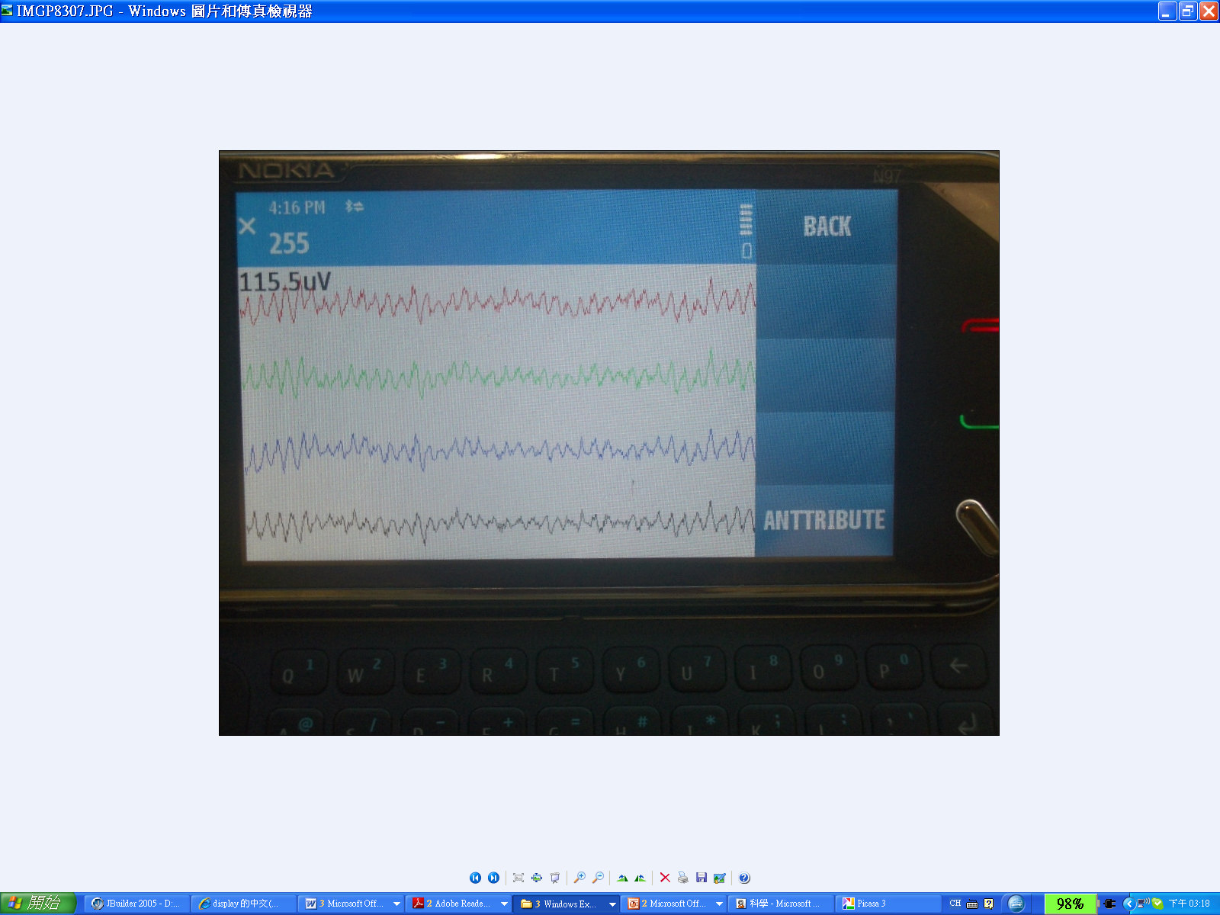
(a)
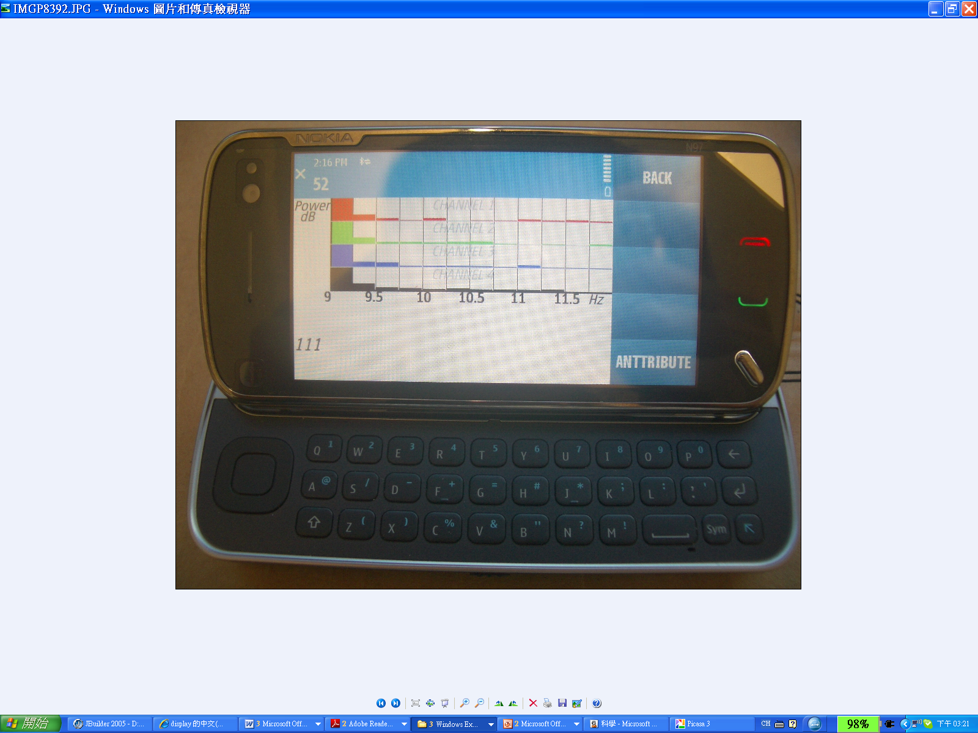
(b)
Fig. 3. Screen snapshots of the cell-phone’s GUI: (a) A time-domain display of the 4-channel EEG, (b) Estimated power spectral density of the EEG when number ‘1’ was attended.

Fig. 4Fig. 4 shows the flow chart of the program. First, the program initiates a connection to the EEG acquisition unit. Next, four-channel raw EEG data are band-pass filtered at 8-20 Hz, and then plotted on the screen every second. The display can be switched to the power spectrum display mode by pressing “shift” + “0” buttons simultaneously, as shown in Fig. 3Fig. 3. A 512-point FFT is applied to the EEG data using a 4-sec. moving window advancing at 1-sec. steps for each channel. To improve the reliability, a target is detected only when the same dominant frequency is detected in two consecutive windows (at time k, and k+1 seconds, k≥4). The subjects are instructed to shift their gaze to the next target (digit) flashed on the screen once they are cued by the auditory feedback.

2.3 BCI Experiment Design
Ten volunteers with normal or corrected to normal vision participated in this experiment. The experiment was run in a typical office room. Subjects were seated in a comfortable chair at a distance of about 60 cm to the screen. Four electrodes on the EEG headband were placed around the O1/O2 area, all referred to a forehead midline electrode.
At the beginning of the experiment, each subject was asked to gaze at some specific digits to confirm the wireless connection between the EEG headband and the cell-phone. Based on the power spectra of the EEG data, the channel with the highest signal-to-noise ratio was selected for online target detection. The test session began after a couple of short practice session. The task was to input a 10-digit phone number: 123 456 7890, followed by an ENTER key to dial the number. Incorrect key detection could be removed by a gaze shift to the “BACKSPACE” key. The percentage accuracy and ITR [1] were used to evaluate the performance of the cell-phone based BCI.
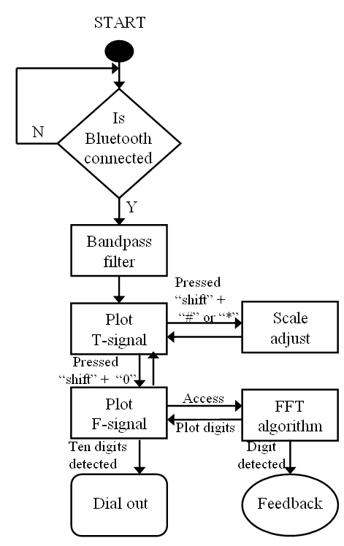
Fig. 4. The flow chart of the program coded on the cell-phone. T-signal refers to the time-domain display, and F-signal refers to the frequency-domain display.

3 Results
Table Ⅱ shows the results of the EEG-based phone-dialing experiments. All subjects completed the EEG-based phone-dialing task with an average accuracy of 95.9±7.4%, and an average time of 88.9 seconds. 7 subjects successfully inputted 11 targets without any error. The average ITR was 28.47±7.8 bits/min, which was comparable to other VEP BCIs implemented on a high-end personal computer [4].

Table Ⅱ. Online test results of 10 subjects.
Subject | Input length | Time(sec.) | Accuracy (%) | ITR
Y.T. | 11 | 72 | 100 | 32.86
C. | 11 | 72 | 100 | 32.86
A. | 19 | 164 | 78.9 | 14.67
Y.B. | 11 | 73 | 100 | 32.4
T.P. | 17 | 131 | 82.4 | 17.6
T. | 11 | 67 | 100 | 35.31
W. | 11 | 72 | 100 | 32.86
B. | 13 | 93 | 92.3 | 20.41
F. | 11 | 79 | 100 | 29.95
D. | 11 | 66 | 100 | 35.85
Mean | 12.6 | 88.9 | 95.9 | 28.47
4 Conclusions and Discussion
This study detailed the design, development, and testing of a truly mobile and wireless BCI for communication in daily life. A lightweight, battery-powered, and wireless EEG headband was used to acquire and transmit EEG data of unconstrained subjects in real-world environments. The acquired EEG data were received by a regular cell-phone through Bluetooth. Signal-processing algorithms and graphic-user interface were developed and tested to make a phone call based on the SSVEPs in responses to frequency-encoded visual stimuli. The results of this study concluded that all of the participants, with no or little practicing, could make phone calls through this SSVEP-based BCI system in a natural environment.
Despite such successes, there is room for improvement. Future directions include: (1) the use of dry EEG electrodes over the scalp locations covered with hairs to avoid skin preparation and the use of conductive gels; and (2) the use of multi-channel EEG signals to enhance the accuracy and ITR of the BCI [18], as opposed to manually selecting a single channel from the recordings.
It is worth noting that, in the current study, the cell-phone was programmed to assess wearers’ SSVEPs for making a phone call, but it can actually be programmed to function in ways appropriate for other BCI applications. In essence, this study is just a demonstration of a cell-phone based platform technology that can enable and/or facilitate numerous BCI applications in real-world environments.

Acknowledgments. This work is supported by a gift from Abraxis Bioscience Inc.
References
- Wolpaw, J.R., Birbaumer, N., McFarland, D.J., Pfurtscheller, G., Vaughan, T.M.: Brain-computer interfaces for communication and control. Clin Neurophysiol 113(6) 767-791 (2002)
- Wang, Y.J., Gao, X.R., Hong, B., Jia, C., Gao, S.: Brain-computer interfaces based on visual evoked potentials - Feasibility of practical system designs. IEEE Eng Med Biol 27 64-71 (2008)
- Regan D.: Human Brain Electrophysiology: Evoked Potentials and Evoked Magnetic Fields in Science and Medicine. New York: Elsevier, (1989)
- Cheng, M., Gao, X.R., Gao, S.G., Xu, D.F.: Design and implementation of a brain-computer interface with high transfer rates. IEEE T. Bio-Med Eng. 49 1181-1186 (2002)
- Wang, Y., Wang, R.P., Gao, X.R., Hong, B., Gao, S.K.: A practical VEP-based brain-computer interface. IEEE Tr. Neur. Sys. Rehab. 14(2), 234--239 (2006)
- Valbuena D., Cyriacks M., Friman O., Volosyak I., Graser A.: Brain-computer interface for high-level control of rehabilitation robotic systems. In: 10th IEEE Int. Conf. Rehab. Robot., pp. 619--625 (2007)
- Jia C., Xu H.L., Hong B., Gao X.R., Zhang Z.G., and Gao S.K.: A human computer interface using SSVEP-based BCI technology. Found. Augmented Cognit., 4565, 113-119 (2007)
- Muller-Putz G.R. and Pfurtscheller G.: Control of an electrical prosthesis with an SSVEP-based BCI. IEEE T. Biomed. Eng. 55(1), 361--364 (2008)
- Wang Y., Gao X., Hong B., and Gao S.: Practical designs of brain-computer interfaces based on the modulation of EEG rhythms. B. Graimann, G. Pfurtscheller (eds.) Invasive and Non-Invasive Brain-Computer Interfaces, Springer, The Frontiers Collection (2009)
- Lin C.T., Ko L.W., Chiou J.C., Duann J.R., Chiu T.W., Huang R.S., Liang S.F., and Jung T.P.,: A noninvasive prosthetic platform using mobile and wireless EEG. Proc. IEEE. 96(7), pp. 1167--1183 (2008)
- Lin, C.T., Ko, L.W., Chang, M.H., Duann, J.R., Chen, J.Y., Su, T.P., Jung, T.P.: Review of Wireless and Wearable Electroencephalogram Systems and Brain-Computer Interfaces - A Mini-Review. Gerontology 56 112-119 (2010)
- Lin C.T., Chen Y.C., Chiu T.T., Ko L.W., Liang S.F., Hsieh H.Y., Hsu S.H., and Duan J.R.,: Development of Wireless Brain Computer Interface With Embedded Multitask Scheduling and its Application on Real-Time Driver’s Drowsiness Detection and Warning. IEEE T. Biomed. Eng., 55, 1582--1591 (2008)
- Gao, X.R., Xu, D.F., Cheng, M., Gao, S.K.: A BCI-based environmental controller for the motion-disabled. IEEE T. Neur. Sys. Reh. 11 137--140 (2003)
- Edlinger G., Krausz G., Laundl F., Niedermayer I., Guger C.: Architectures of laboratory-PC and mobile pocket PC brain-computer interfaces. Proc. 2nd Int. IEEE EMBS Conf. Neural Eng., Arlington, VA, 120--123 (2005)
- Whitchurch K., Ashok B.H., Kumaar R.V., Sarukesi K., Varadan V.K.: Wireless system for long term EEG monitoring of absence epilepsy. Biomed. Appl.Micro. Nanoeng., 4937, 343--349 (2002)
- Obeid, Nicolelis M.A.L., and Wolf P.D.: A multichannel telemetry system for signal unit neural recording. J. Neurosci. Methods, 133, 33--38 (2003)
- Shyu, K.K., Lee, P.L., Lee, M.H., Lin, M.H., Lai, R.J., Chiu, Y.J.: Development of a Low-Cost FPGA-Based SSVEP BCI Multimedia Control System. IEEE T. Biomed. Circ S. 4125--132 (2010)
- Bin, G.Y., Gao, X.R., Yan, Z., Hong, B., Gao, S.K.: An online multi-channel SSVEP-based brain-computer interface using a canonical correlation analysis method. J Neural Eng 6 (2009)

